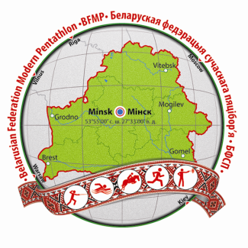 | European Junior Championships,  Minsk, Belarus  17-23 June, 2014

ENTRY FORM “A” (Informative)

Return no later than April 17, 2014

Please complete using capital letters

Nation: _______________________ Contact Person:_________________________

Tel : ______________ Fax :_______________ E Mail: _______________________

PARTICIPATION:
Estimated Number of Persons
Men Women

Athletes

Coaches /Officials

Others

Relay MIX

Traditional Relay

ACCOMODATION: Mark with “X”

The Delegation will stay in the Official Hotel YES NO
IF YES:
Single rooms n. _______ from_____________ to____________
Double rooms n. _______ from_____________ to____________

Signature: _________________________Name (printed):___________________________

Date: _____________

Return to: Belarusian Federation of Modern Pentathlon, contact person Elena Iskhacova
E-mail: blrpentathlon@mail.ru

